Following are the tyes of RNN:
- Many to many
- Many to one
- One to one
- One to many

Many to One:

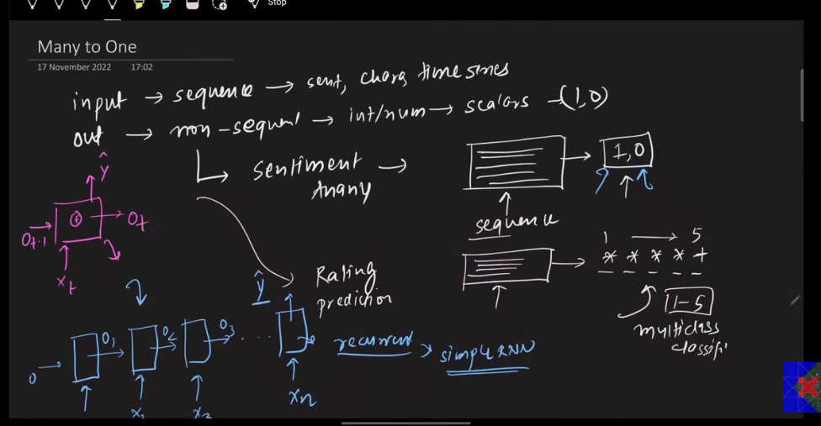

Many to one, has many inputs but one output, for example sentiment analysis, we have a review we break it down into tokens, convert into integer or embedding, pass each word one by one and when all the words end we get a prediction, we have given multiple inputs of first review but only one output.

Examples:
- Sentences
- Time series
- Characters

One to Many:
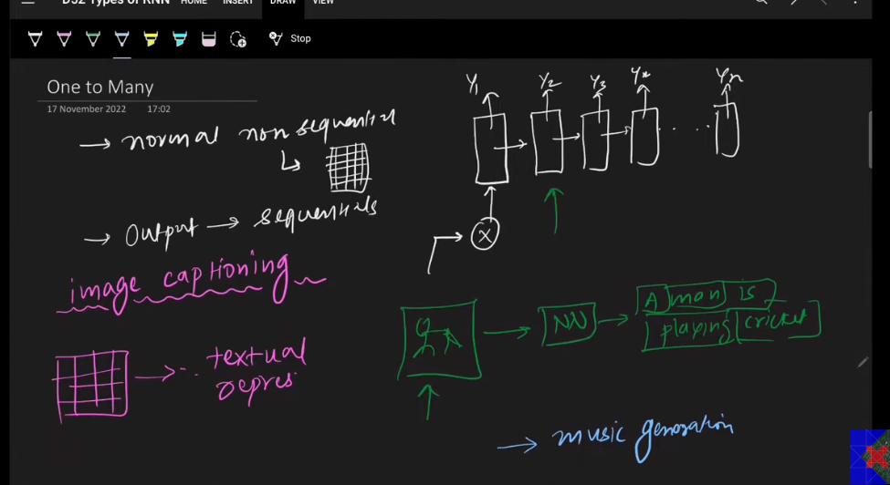

Ismy ham input aik hi dety hain jaisay image, aik image likin output multiple hoty hain. For example image captionaing aik image pass karo or output mn image ky captions generate hon aik sy zyada.
Dsri example musical notes generation, ky aik input mily or constantly music generate hota rahay.

Many to many:
Input mn sequential data or output mn bhi sequential data
It has two types:
- Same length many to many.
- Variable length many to many.

Same length:
For example Parts of Speech tagging.
Input: My name is nitish
Output: Noun(my) noun (name) verb(is) noun (nitish)
4 inputs and 4 outputs.
Variable length:
For example machine translation.
Input: Hi! My name is ahsan (English 5 words)
Output: mera nam ahsan hai (4 in urdu language)
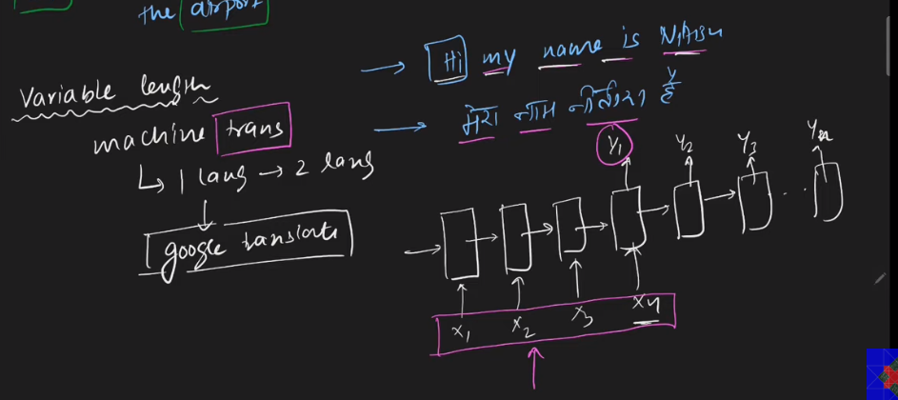

One to One:
Input: non-sequential
Output: non-sequential
Example: Image classification
Technically it is not RNN, it is a simple Neural network.

